**Name: Manasi Jadhav**

**UID:2018140025**

**Batch: B**

**TE-IT**

**Expt-2: Employee Management System using JSP and servlet**

**Registration Page**

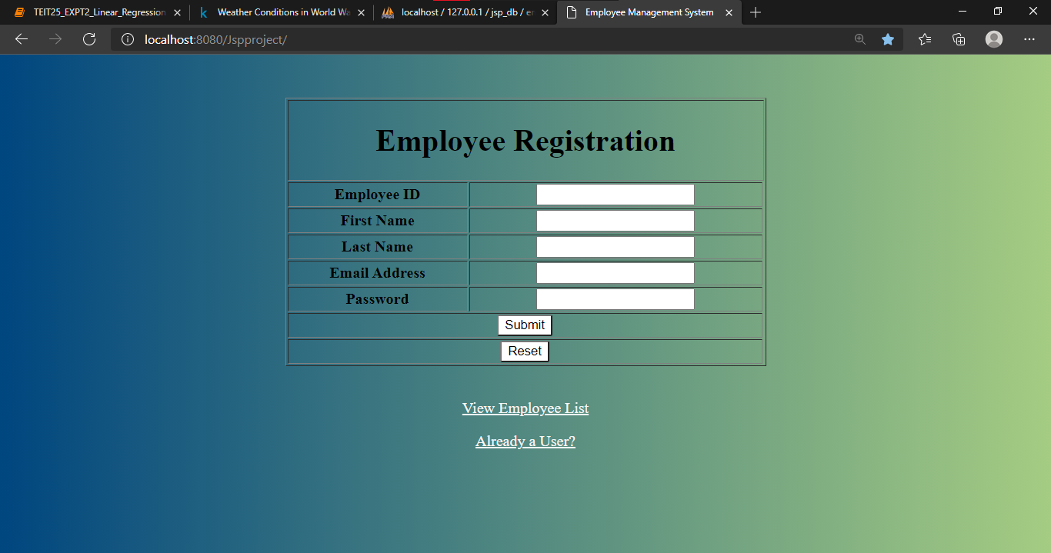

**Mysql Database**

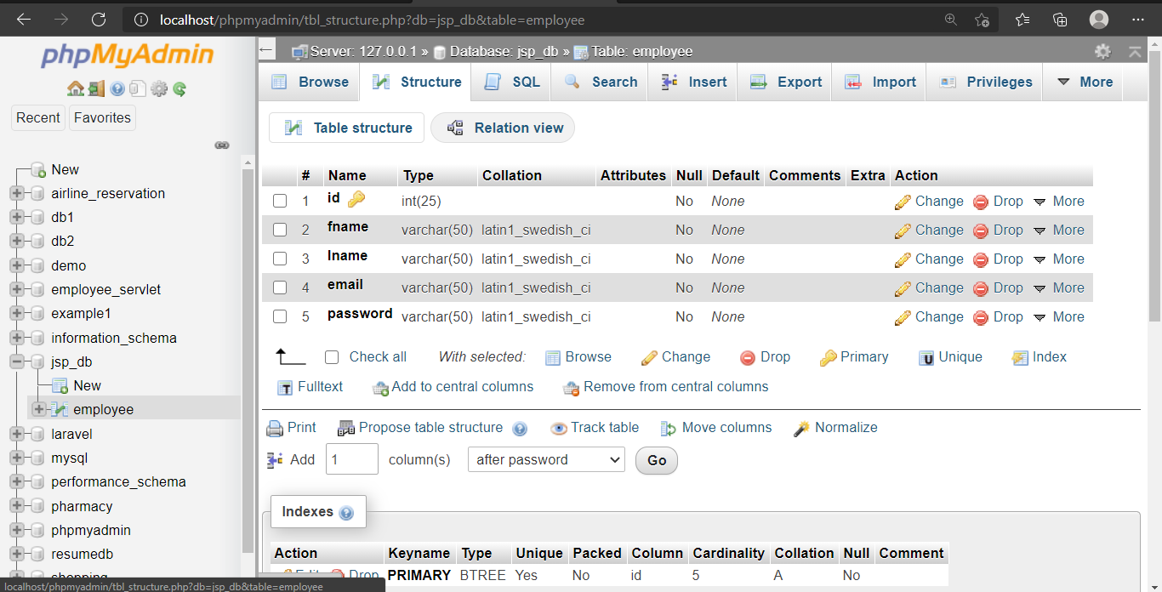

**Entries in database**

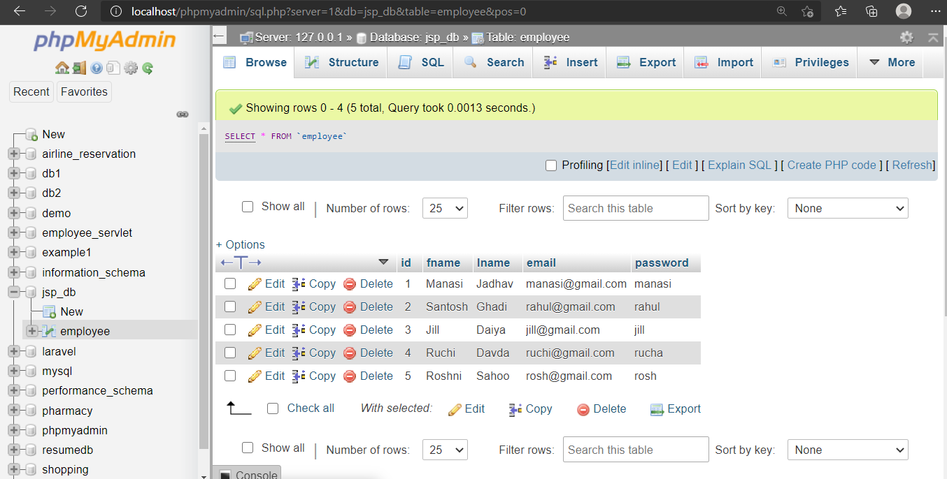

**Register employee ‘Esha’**

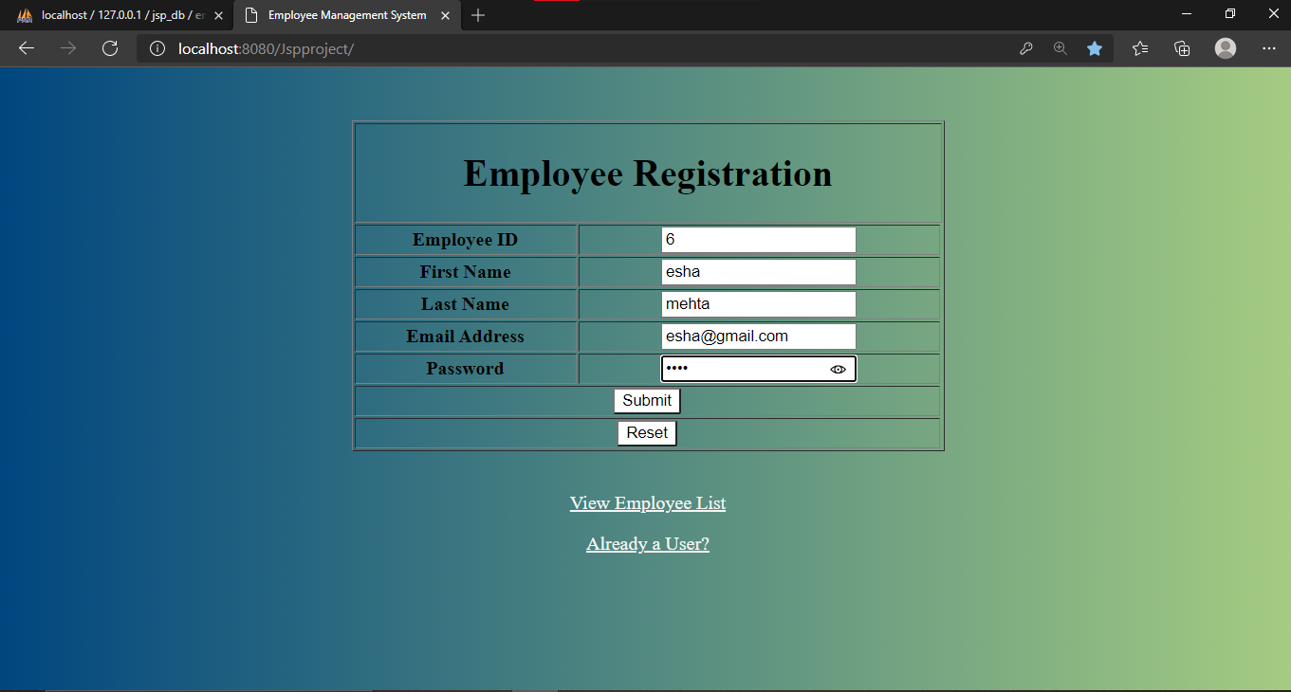

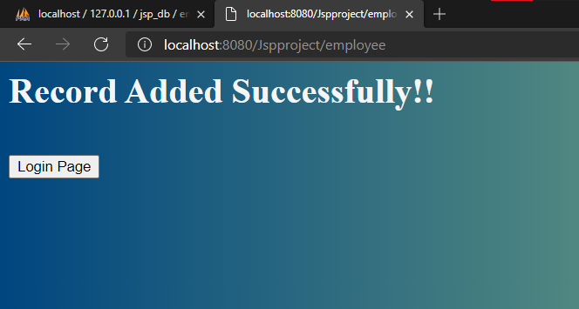

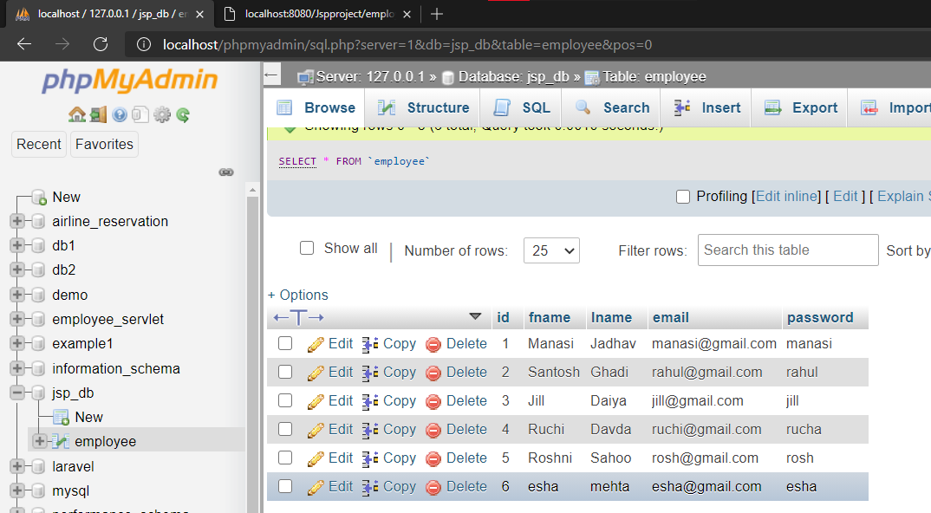

**Login Page**

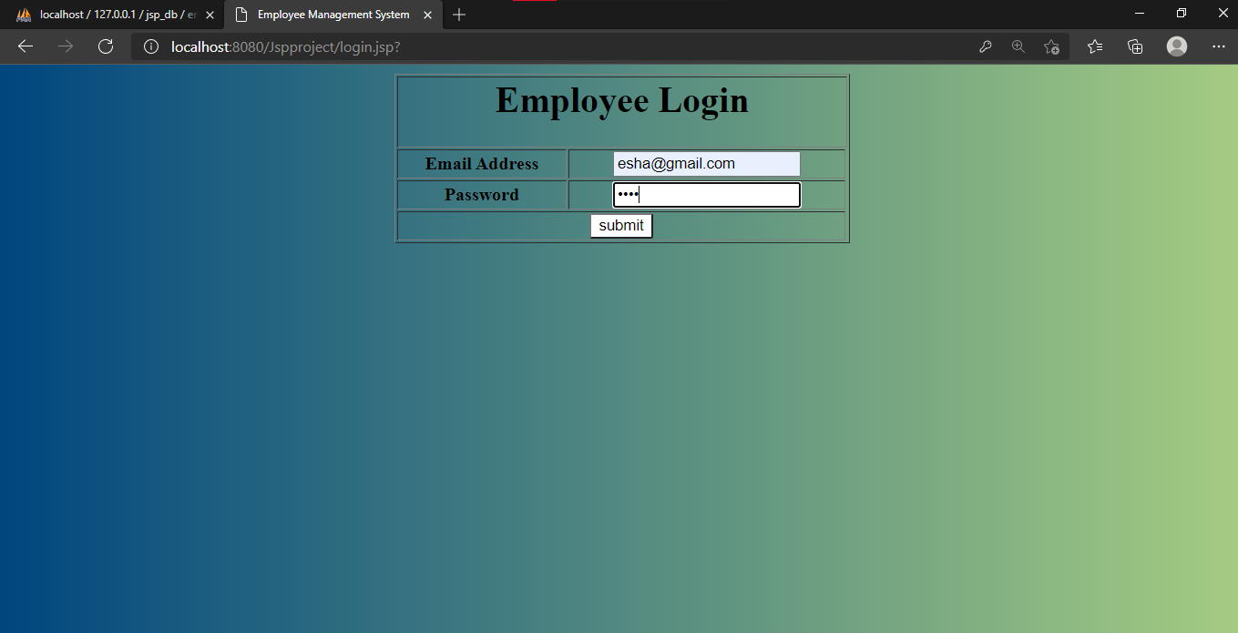

**Welcome Page**

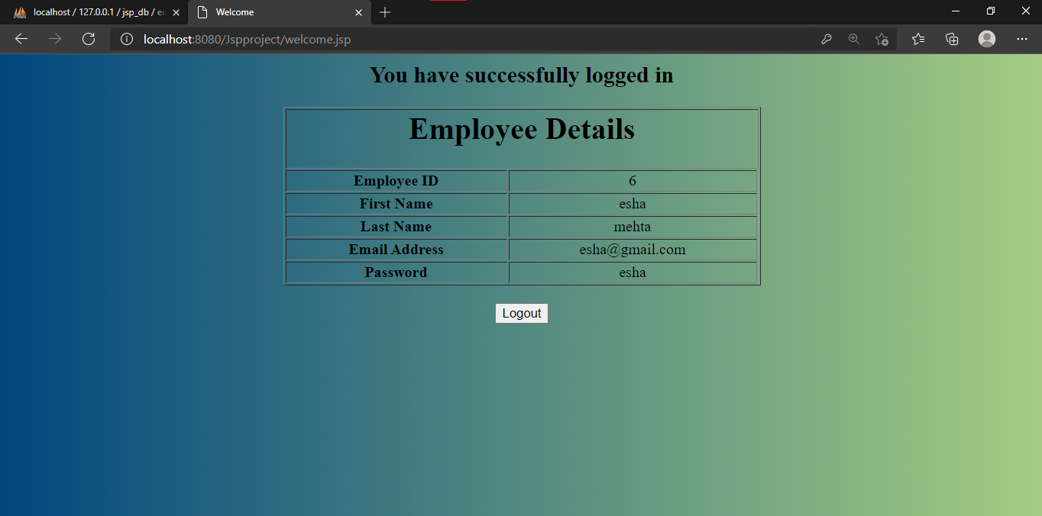

**View all Employees**

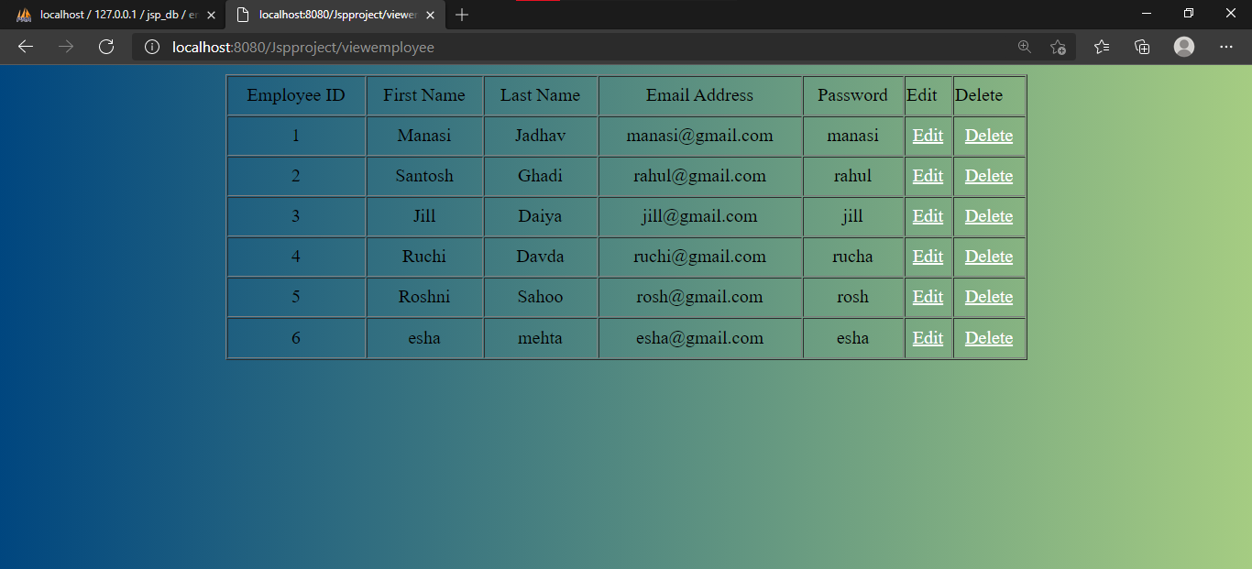

**Edit Employee Page**

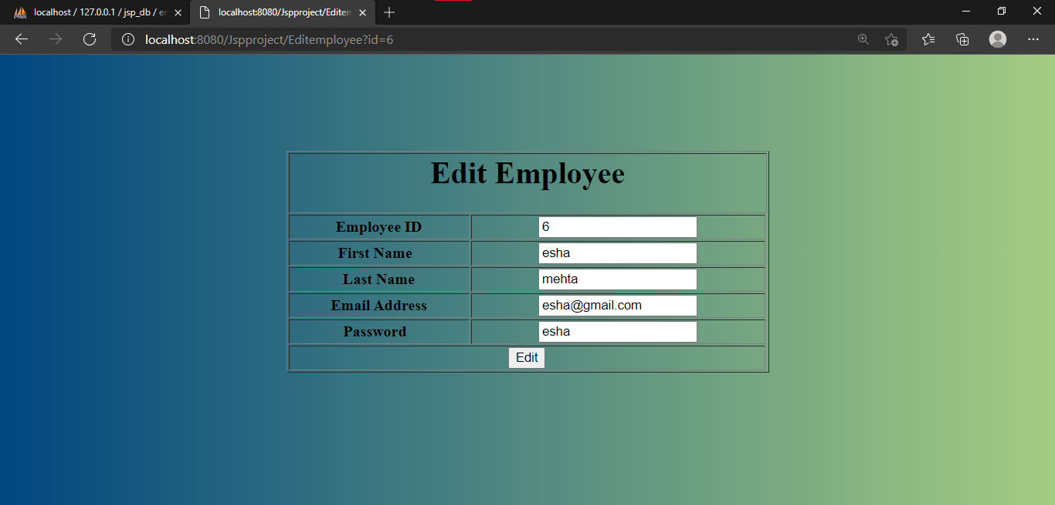

**Editing Employee details of Esha**

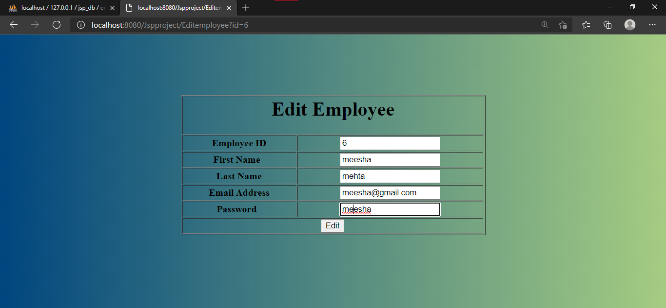

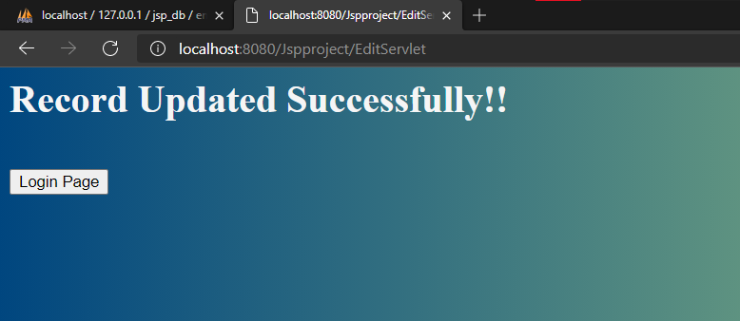

**Record updated in database**

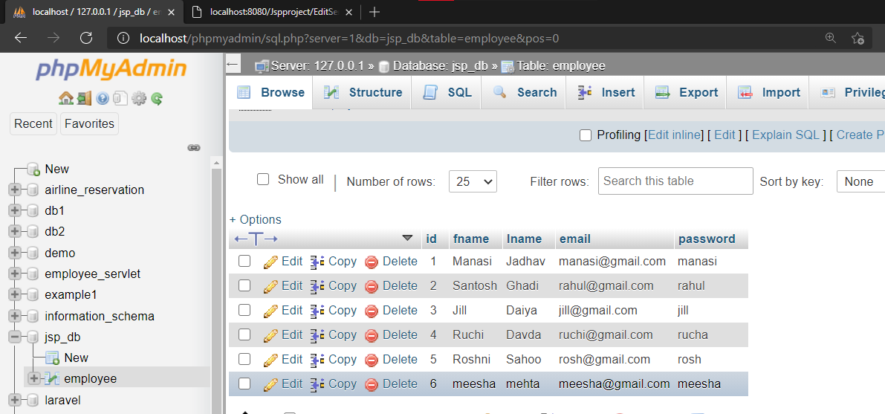

**For deleting a record click on ‘Delete’. Let’s delete record of meesha**

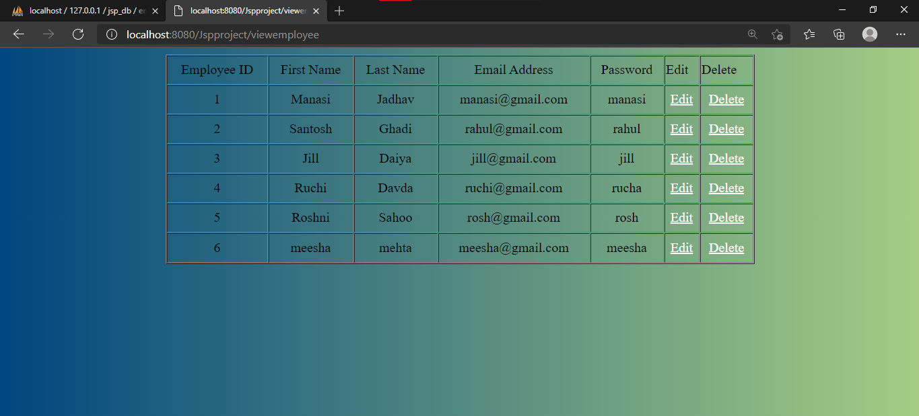

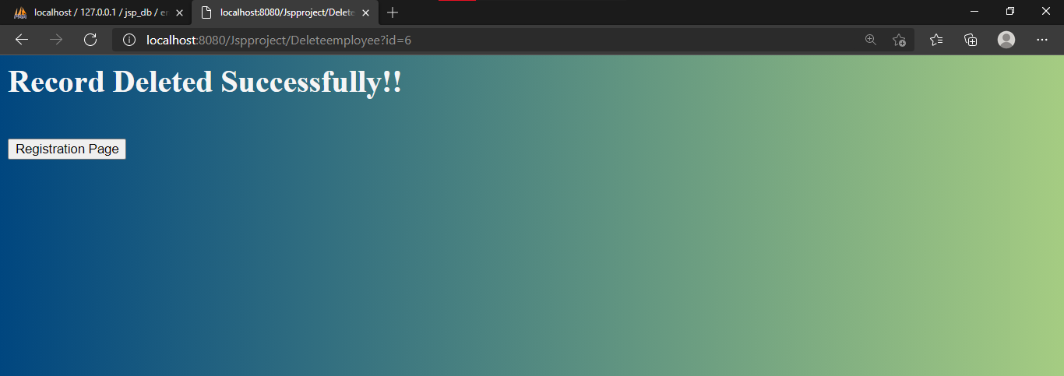

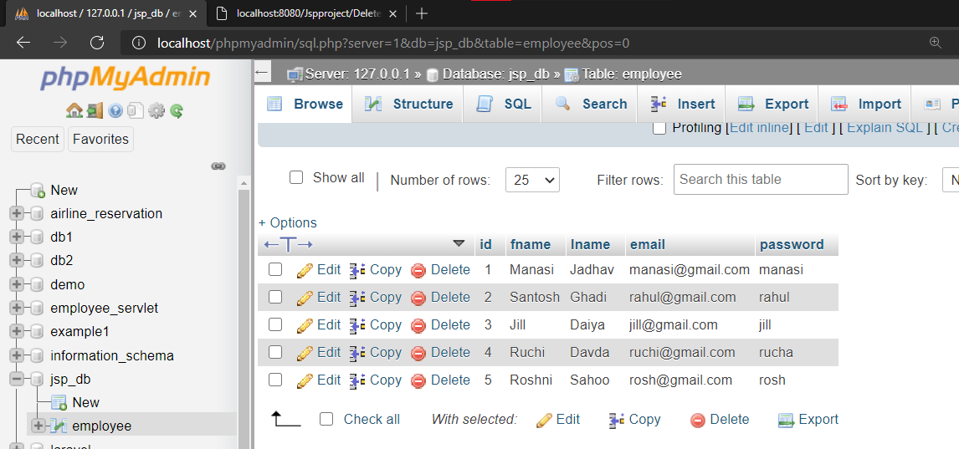

**Conclusion:**

Learnt to make a website using JSP and Servlet.